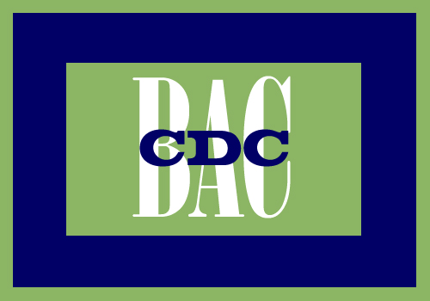
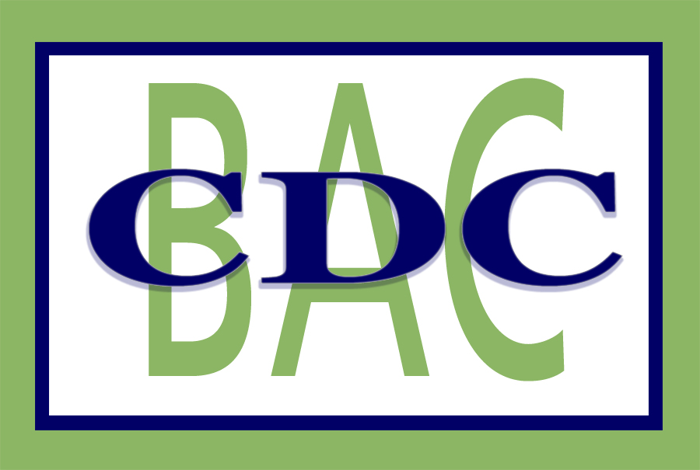
Quaboag Valley
Community Development Corporation
& Quaboag Valley Business Assistance Corporation

MINI GRANT APPLICATION
For Businesses with Fewer than 20 Employees

Name___________________________ _____ Title___________________________ Phone(s) ____________________________

Business Name________________________________________ Email ____________________ FAX__________________

Business Address______________________________________________________________________ _Zip___________________

- Determine which category you qualify for (must meet all of the conditions under that category and attach documentation):

□ Established Business
□ > 1 year in business
□ DBA certificate or incorporation
□ Fed. ID# if employees
□ One of the following:
□ Proof of tax returns within past three years; or
□ Proof of employing at least one full time
equivalent employee

Grant Amount: up to $750.00
□ Start-Up Business
□ < 5 years in business
□ DBA certificate or incorporation
□ Fed. ID # if employees
□ Evidence of business activity
through internal financial reports

Grant Amount: up to $500.00
□ Pre-Venture
□ Planning stage
□ Have definite business idea
□ No actual business activity

Grant Amount: up to $300

Staff Certification:

Staff Certification:

Staff Certification

:

What will we pay for? Grants are intended to increase the capacity of the business by providing professional services, education or training. Grant funds are not intended for equipment, supplies, purchases, employees or other ongoing business expenses. Grants will be paid directly to Vendors (consultants or trainers) after they sign a three-way agreement among you, the consultant and the QVCDC and complete the work to your satisfaction. The QVCDC will pay no more than $75/hour for services. You are encouraged (but not required) to supplement this QVCDC grant with your own funds, if needed, to complete your project. Funds are limited and treated on a first-come, first-served basis, provided all documentation, proposals and contracts are in place in a timely fashion (see 30 day policy, page 2). QVCDC reserves the right to deny applications not meeting these criteria or not providing complete documentation of eligibility before program funds expire.

- State the work that needs to be done: ___________________________________

______________________________________________________________________________________________________________________________________________________________________________________________________3. How will this help your business: _____________________________________________________________
__________________________________________________________________________________________________

- Identify your consultant -- Choose a, b, c or d

- □ I will choose my own □ I have already contacted this consultant

- Requested Assistance Preferred Consultant Name and # hours Cost Estimate
Contact Information proposed (if available)

________________________ _____________________________ ______ __________

- □ If available, please provide me with a list of consultants in this field
- □ Please contact me to discuss options.

- Last Step: Authorize Contract
We need to establish an agreement between you and your preferred consultant. Once you have identified your consultant, we will send you a simple one-page proposal which both you and your consultant must sign. By signing this, you both agree to the proposed work including the final cost and amount of time. If the cost exceeds our grant, you must pay the difference directly to the consultant yourself. We do not certify consultants however we do require that consultants show proof of competency when applicable (e.g., license, certification), proof of workers’ compensation insurance, if applicable, and complete a W9 form for tax purposes.

Please initial on the line provided:
____I understand that all information provided by the QVCDC or an independent consultant may be accepted or rejected at my discretion at any time. I agree to hold the Quaboag Valley CDC (QVCDC), any third party representative and/or independent consultant harmless against any liability, loss or damage cause by or arising from the use of any and all information or materials furnished by the QVCDC, representative and/or independent consultant in connection with my participation therein
____I certify that all of the information provided in this application is true and correct to best of my knowledge. I further understand the information that I provide may be verified by a third party and it may be used to determine eligibility for program services.
____I certify that I/ am over 18 years of age, that I agree to the terms and conditions of this application and that I am responsible for ensuring that the work for which I may be deemed eligible is completed in a timely manner.
____By submitting this application, I agree to provide QVCDC and it’s funders with follow up reports and/or surveys about my business.
____I give my permission to the Quaboag Valley Community Development Corporation (QVCDC) to use my name, the name of my business/organization, and/or my picture or a picture of my business or organization for the purpose of promoting their programs, reporting on their programs, or securing additional funds for their programs.

Signed: ____________________________________ Title: _______________________________ Date: _____________________
---------- POLICIES ----------
Our 30-day Policy: In an attempt to move projects along and to share grant resources among as many businesses as possible, we have instituted the following policy;
- Incomplete applications will be allowed 30 days to provide all application documentation.
- Completed (certified eligible applications) will be allowed 30 days from certification notice to identify a consultant.
- All 3-way contracts among business, consultant and QVCDC will be allowed 30 days for completion. After that, contracts will be terminated, barring pre-approved circumstances.

Remaining Grant Policy: Businesses that have completed a contract but have not used up the maximum allocation for the business category ($750, $500 or $300), may return to the end of the certified eligible applications queue and be in line for additional assistance, if funding persists.

Serving: Belchertown, Brimfield, Brookfield, East Brookfield, Hardwick, Holland, Monson, New Braintree, North Brookfield,
Palmer, Spencer, Wales, Ware, Warren, West Brookfield

The Quaboag Valley CDC/BAC is an equal opportunity employer, lender and provider and does not discriminate on the basis of age, color,
disability, family/parental status, national origin, race, religion, sex, gender identity (including expression), sexual orientation, marital status,
income derived from public assistance programs, political beliefs, or reprisal or retaliation for prior civil rights activity in any program or activity
conducted or funded by USDA

