**Create and add an email message signature (Outlook 2010)**

You can create personalized signatures for your email messages that include text, images, your electronic business card, or a logo. Your signature can automatically be added to outgoing messages, or you can manually add the signature to only the messages that you choose.

1. Open a new message. On the **Message** tab, in the **Include** group, click **Signature**, and then click **Signatures**.

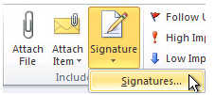

1. On the **E-mail Signature** tab, click **New**.
2. Type a name for the signature, and then click **OK**.

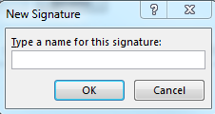

1. In the **Edit signature** box, Copy the below text and images

*__________________________________________________*

*Your FirstName LastName- goes here*

Your Title – goes here

CC Logo - Minelli - for email

1000 Massachusetts Avenue

Cambridge MA 02138

Direct: (617) 873-0XXX (if you have a Direct dial number, replace the last XXX with last 3 of your Extension.)

Tel: (617) 868-1000 Ext. XXXX  (update your 4digit Extension by replacing XXXX)

[www.cambridgecollege.edu](http://www.cambridgecollege.edu/)

facebook.com/cambridgecollege

[linkedin](http://www.linkedin.com/company/cambridge-college)[youtube](http://www.youtube.com/user/CambridgeCollegeTV)[twitter](https://twitter.com/CambridgeCollg)[facebook](https://www.facebook.com/cambridgecollege)

and paste it into the Edit Signature box. Personalize the elements of the signature with your:

* First name and last name
* Title
* Direct phone number
* Your extension

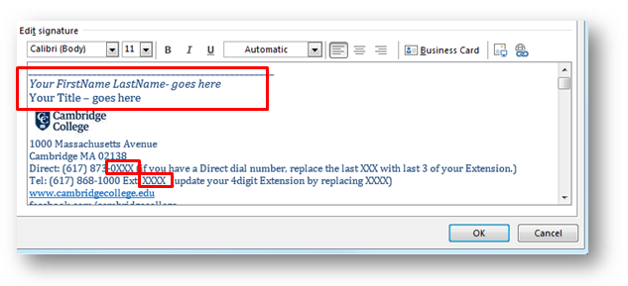

1. Once everything looks good, Under **Choose default signature**, in the **E-mail account** list, click your email account with which you want to associate the signature.

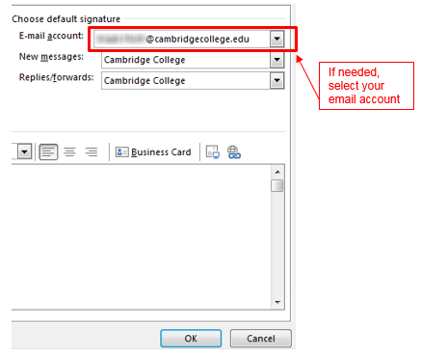

In the **New messages** list, select the signature that you want to include.

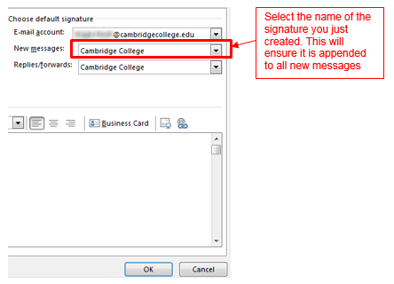

If you want a signature to be included when you reply to or forward messages, in the **Replies/forwards** list, select the signature. Click **OK** to save.

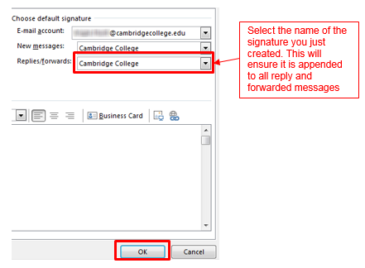

If you have any issues at all with this process or need assistance, please contact the Cambridge College IT Helpdesk by entering a Helpdesk request at <https://helpdesk.cambridgecollege.edu>

You may also send an email to [Helpdesk@cambridgecollege.edu](mailto:Helpdesk@cambridgecollege.edu), or call our 24/7 service line at 617-873-0261 or 1-800-877-4723 ext. 0159.